**Program no____6____**

**Program Title______PIR_________**

**Aim The lights turns on if there is any motion in the range**

**Hardware Required**

* Arduino Board

LED

PIR sensor

Resistor

**Circuit Diagram**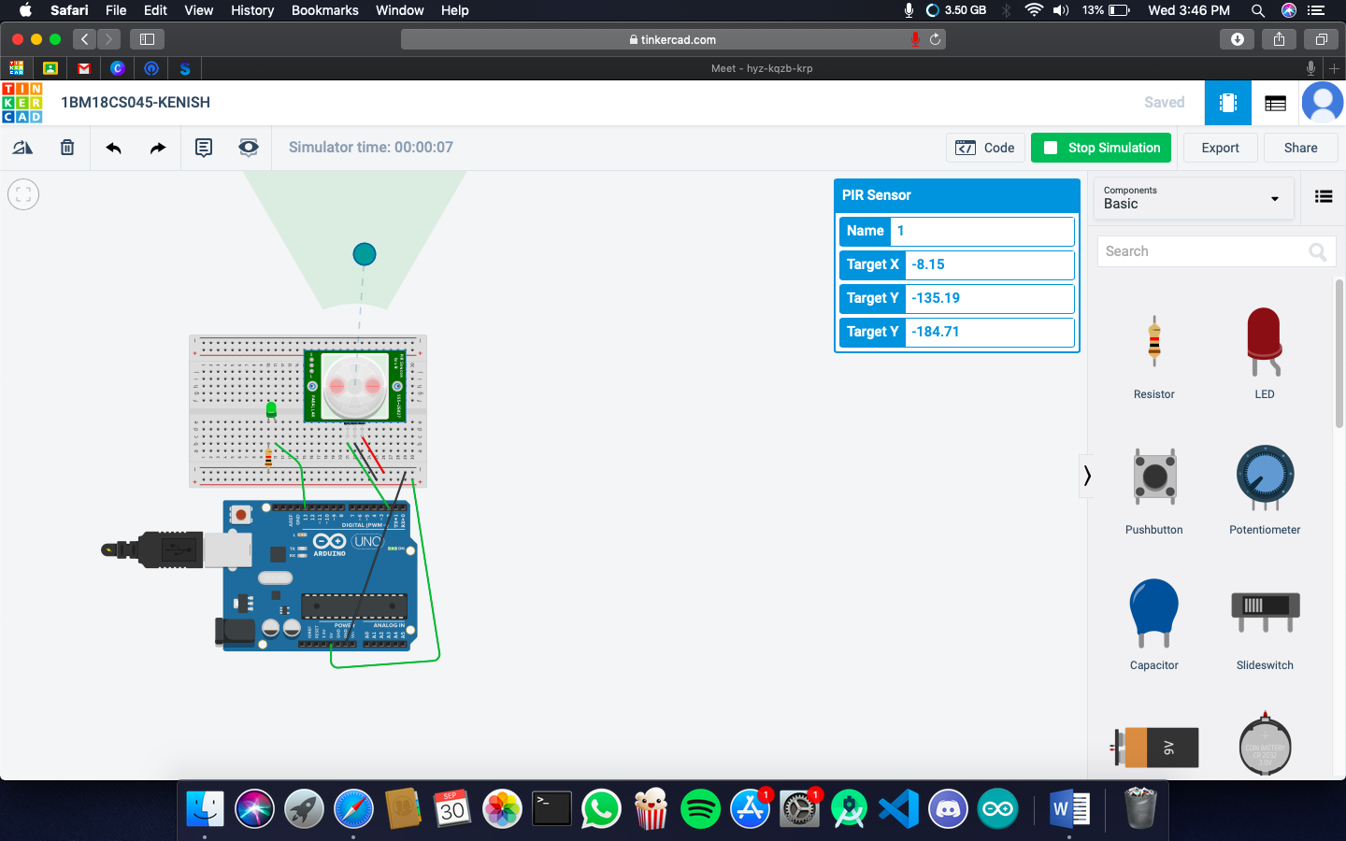

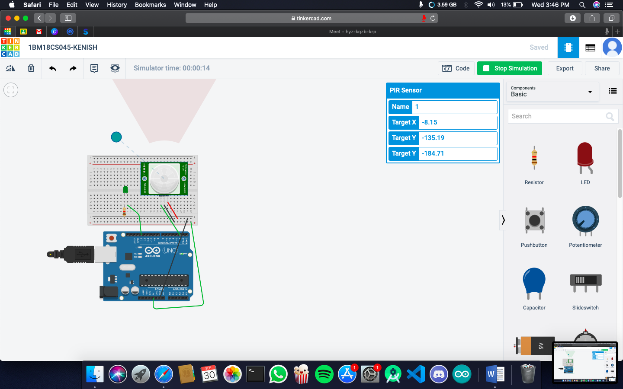

**Code:**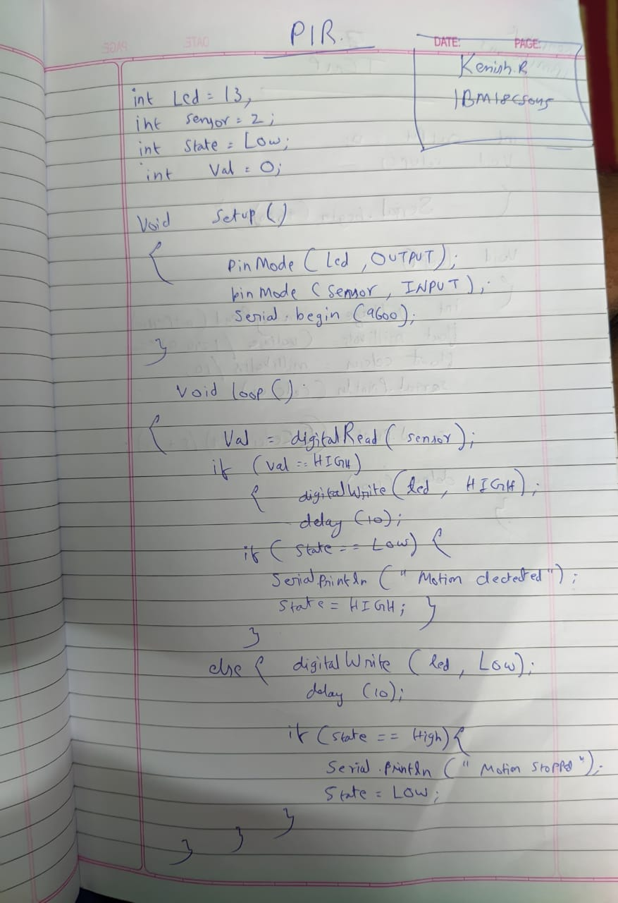

}**Observation /Output**

**The lights turns on if there is any motion in the range**